Script Structure
Writing a script can feel overwhelming when you don’t know where to start or what comes next.
But with a simple, repeatable structure, scripting becomes much faster and easier.
Over time, this approach I'm going to teach you helps you:
- Save Time: Reuse the structure to eliminate guesswork.
- Improve Retention: Analyze your video’s performance by identifying which sections hold or lose viewers.
- Deliver Consistent Value: Keep your message clear and focused across all your videos.

The Basic Structure of a Script
A great YouTube script is like a wall made of bricks.
Each brick builds on the previous one, stacking together to form a cohesive beginning, middle, and end.
Here’s the basic structure:
- Introduction (Hook + Setup): Grab the viewer’s attention and set up the value of the video.
- Body (Points + Payoffs): Each point you make consists of:
  - The problem.
  - How you’ll solve it.
  - An example.
  - Application for the viewer.
  - A teaser for the next point.
- Conclusion (Final Setup + Call to Action): Recap the main points and direct viewers to the next video.
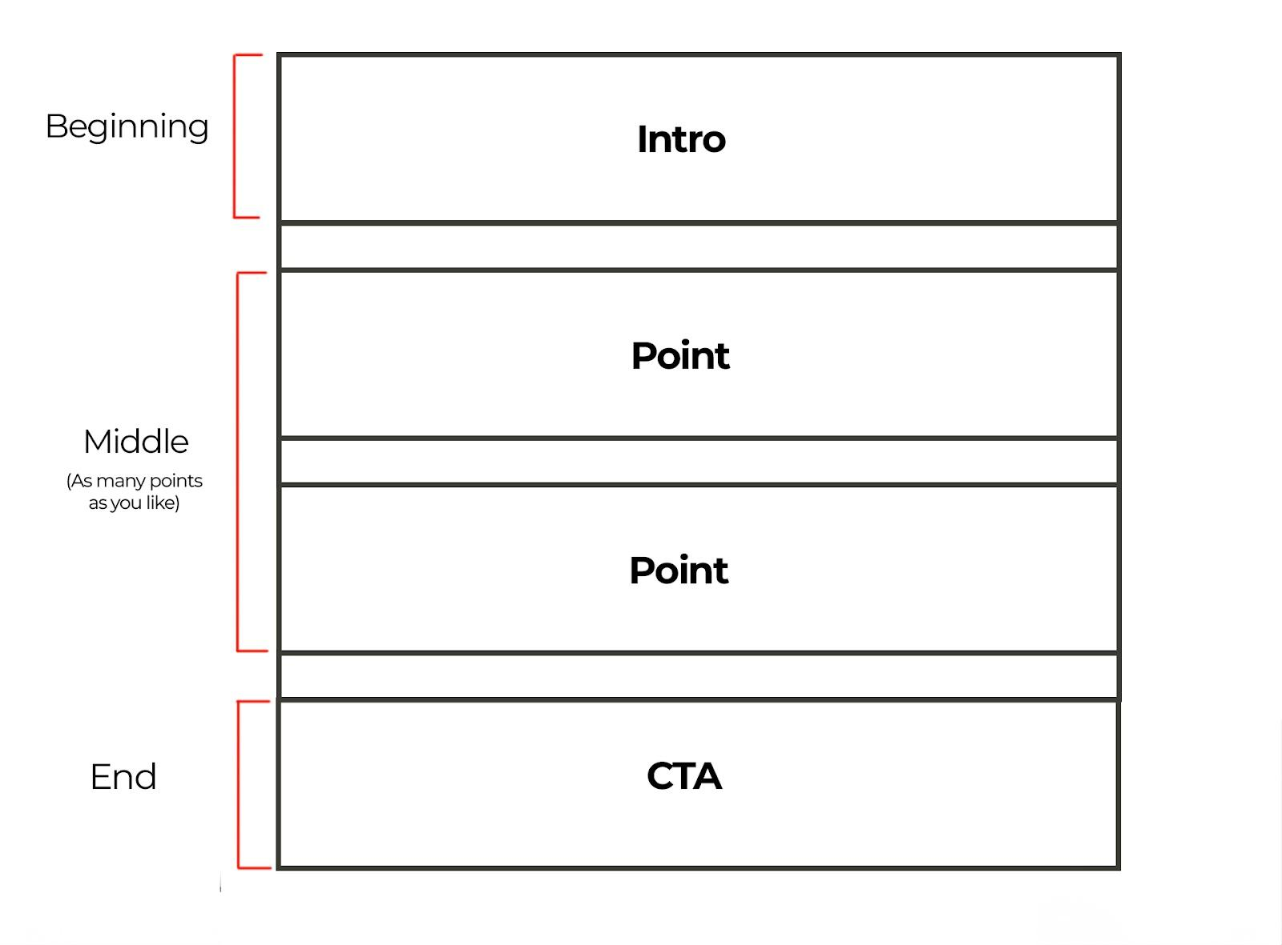

How It Works in Practice
In its simplest form, every section of the video follows a repeatable pattern:
- “You have a problem.”
- “Here’s how I’ll help you solve it.”
- “Here’s an example of how it works.”
- “Here’s how you can apply it yourself.”
- “Watch this next, because it’ll solve another problem you have.”

Example for a Script Covering 3 Points (Please don't use this as a template, it's just a very simplified version to help you understand, )
INTRO:
- You have a problem.
- I’m going to help you solve it.
Point 1:
- You have a problem.
- I’m going to help you solve it.
- Here’s an example of how it works.
- Here’s how to apply it yourself.
- Watch this next because it’ll solve another problem you have.
Point 2: (Repeat the same structure as Point 1)
Point 3: (Repeat the same structure as Point 1)
OUTRO:
- You have a problem.
- Watch this next because it’ll solve another problem you have.

Why This Structure Works
- Clarity: It keeps your video focused and easy to follow.
- Scalability: You can apply this structure to a single-point video or multiple points.
- Retention: By addressing problems and teasing solutions, you encourage viewers to keep watching

The BENS Framework
Each part of your script should incorporate BENS principles to keep it engaging:
- B (Big): Make big claims that excite viewers about the value of your content.
- E (Easy): Present your solutions in a way that feels simple and achievable.
- N (New): Frame your advice as fresh and unique, even if it’s a new perspective on an old idea.
- S (Safe): Write in a way that builds trust by simplifying complex topics and showing credibility.

Practical Tips for Success
- Practice Makes Perfect: Your first scripts might feel clunky, but practice will make the process faster and smoother.
- Use the Brick Wall Analogy: Think of each part of your script as a brick that builds the foundation for your next video.

